**Product Analytics Frameworks:**

Product Analytics Framework is a set of guidelines and processes that businesses use to collect, analyse, and act on data about their products.

1. **AARRR (Pirate Metrics)**:

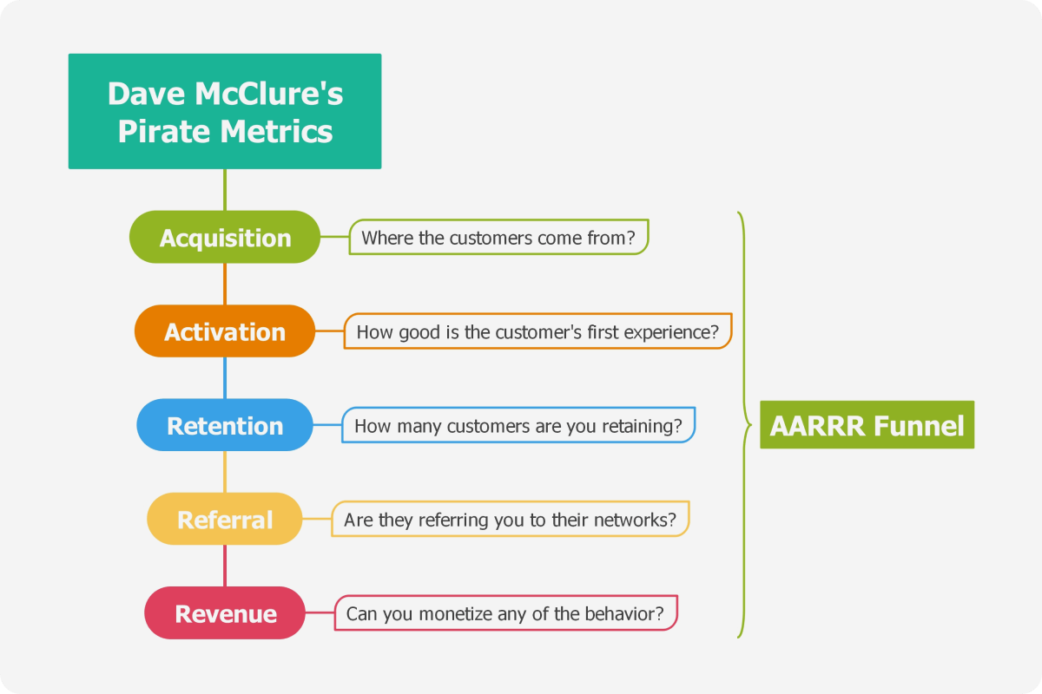

* + **Acquisition**: This stage focuses on getting new users or customers. Examples include:
    - Running targeted Facebook ads to attract potential users.
    - Implementing referral programs to encourage existing users to invite others.
  + **Activation**: After acquisition, you want users to experience the core value of your product. Examples:
    - In a fitness app, users completing their first workout session.
    - In a social media platform, users connecting with friends.
  + **Retention**: Keeping users engaged over time. Examples:
    - Sending personalized emails to inactive users.
    - Offering discounts to returning customers.
  + **Referral**: Encouraging users to refer others. Examples:
    - Dropbox’s referral program where both the referrer and the new user get extra storage space.
    - Airbnb’s referral program for hosts and guests.
  + **Revenue**: Monetizing users. Examples:
    - Subscription fees for premium features.
    - In-app purchases in mobile games.

1. **HEART:** 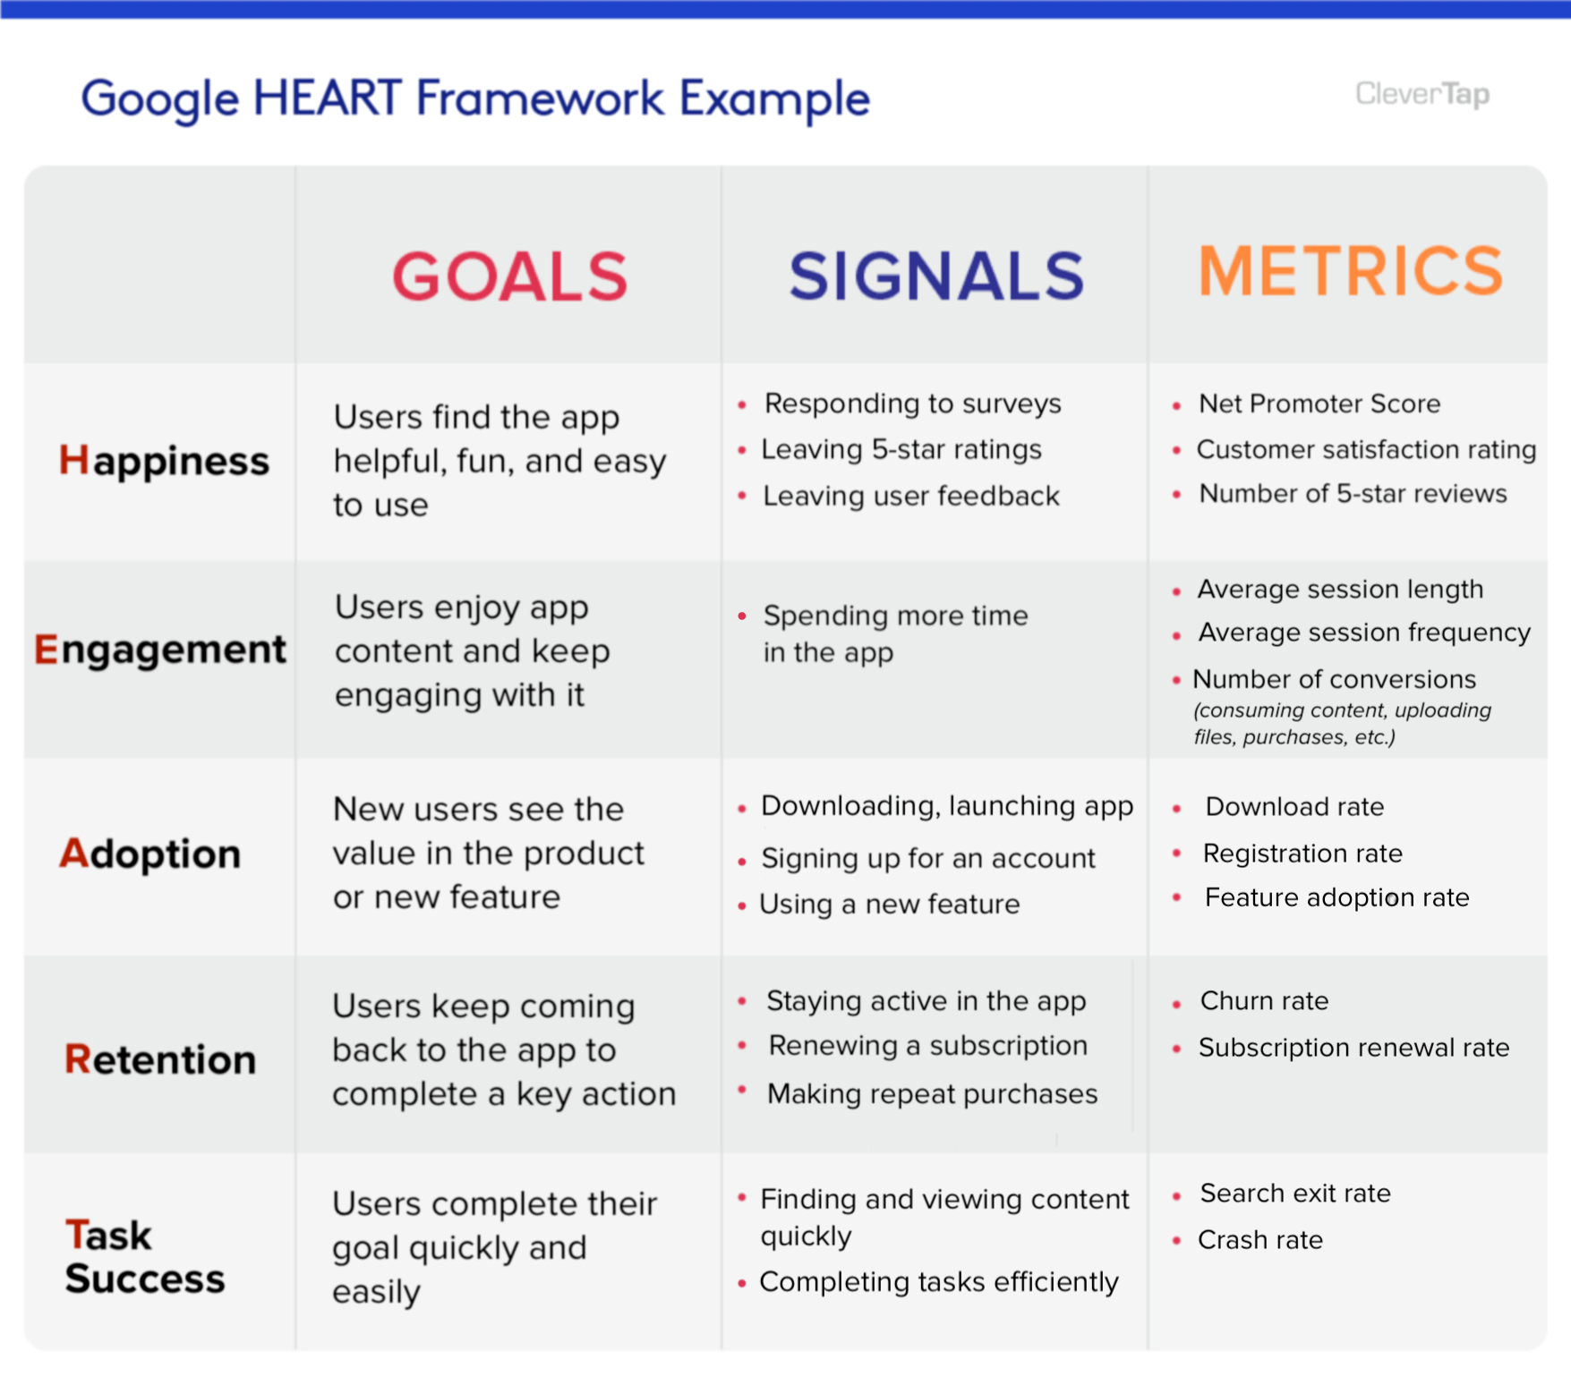
   * **Happiness**: Measuring user satisfaction. Examples:
     + Net Promoter Score (NPS) surveys.
     + Tracking user complaints or support tickets.
   * **Engagement**: How often users interact with your product. Examples:
     + Daily active users (DAU).
     + Time spent per session.
   * **Adoption**: How quickly users adopt new features. Examples:
     + Percentage of users who try a new feature within a week.
     + Onboarding completion rate.
   * **Retention**: Similar to AARRR, retaining users over time.
   * **Task Success**: How well users achieve their goals. Examples:
     + Conversion rate (e.g., signing up, making a purchase).
     + Error rates during critical tasks.
2. **RICE:** 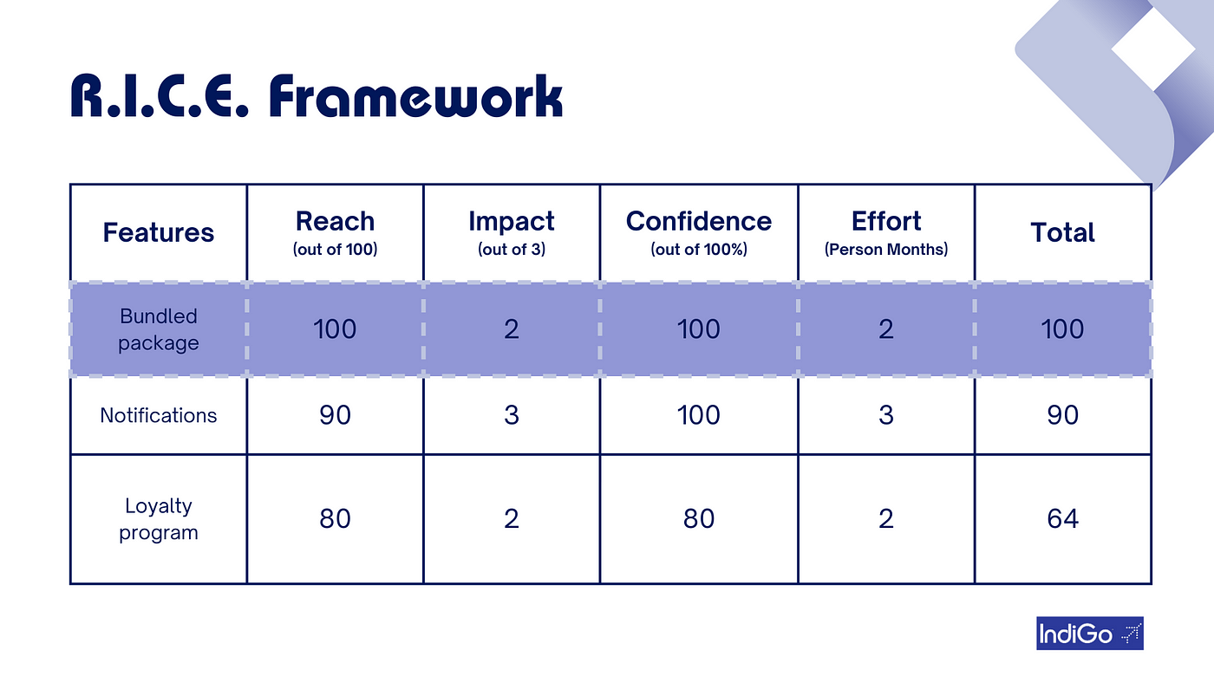
   * Imagine you’re a product manager deciding between two features:
     + **Feature A**: Estimated to impact 10% of users significantly, but it’s challenging to implement (high effort).
     + **Feature B**: Easier to implement (low effort), but it will only impact 5% of users.
   * Calculate RICE score:
     + **Reach**: Feature A reaches more users (10% > 5%).
     + **Impact**: Feature A has a higher impact.
     + **Confidence**: You’re more confident about Feature A.
     + **Effort**: Feature A requires more effort.
   * RICE score for Feature A: High Reach × High Impact × High Confidence / High Effort = High RICE score.
3. **Lean Analytics:** 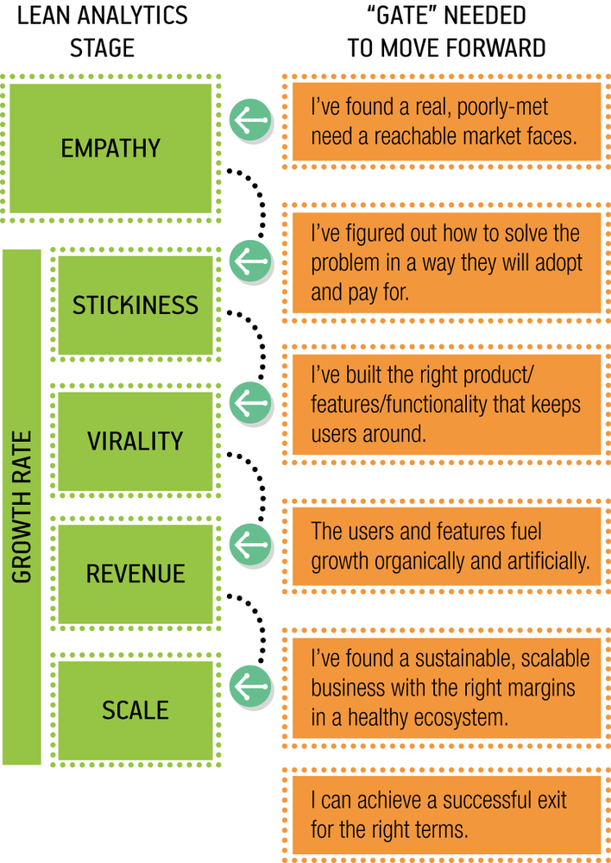
   * Imagine you’re launching a new e-commerce platform:
     + **Empathy**: Understand customer pain points (e.g., long checkout process).
     + **Stickiness**: Measure user engagement (e.g., repeat visits, time spent).
     + **Virality**: Track referrals and social sharing.
     + **Revenue**: Monitor conversion rates, average order value.
     + **Scale**: Prepare for growth (e.g., server capacity).
4. **KANO Model:** 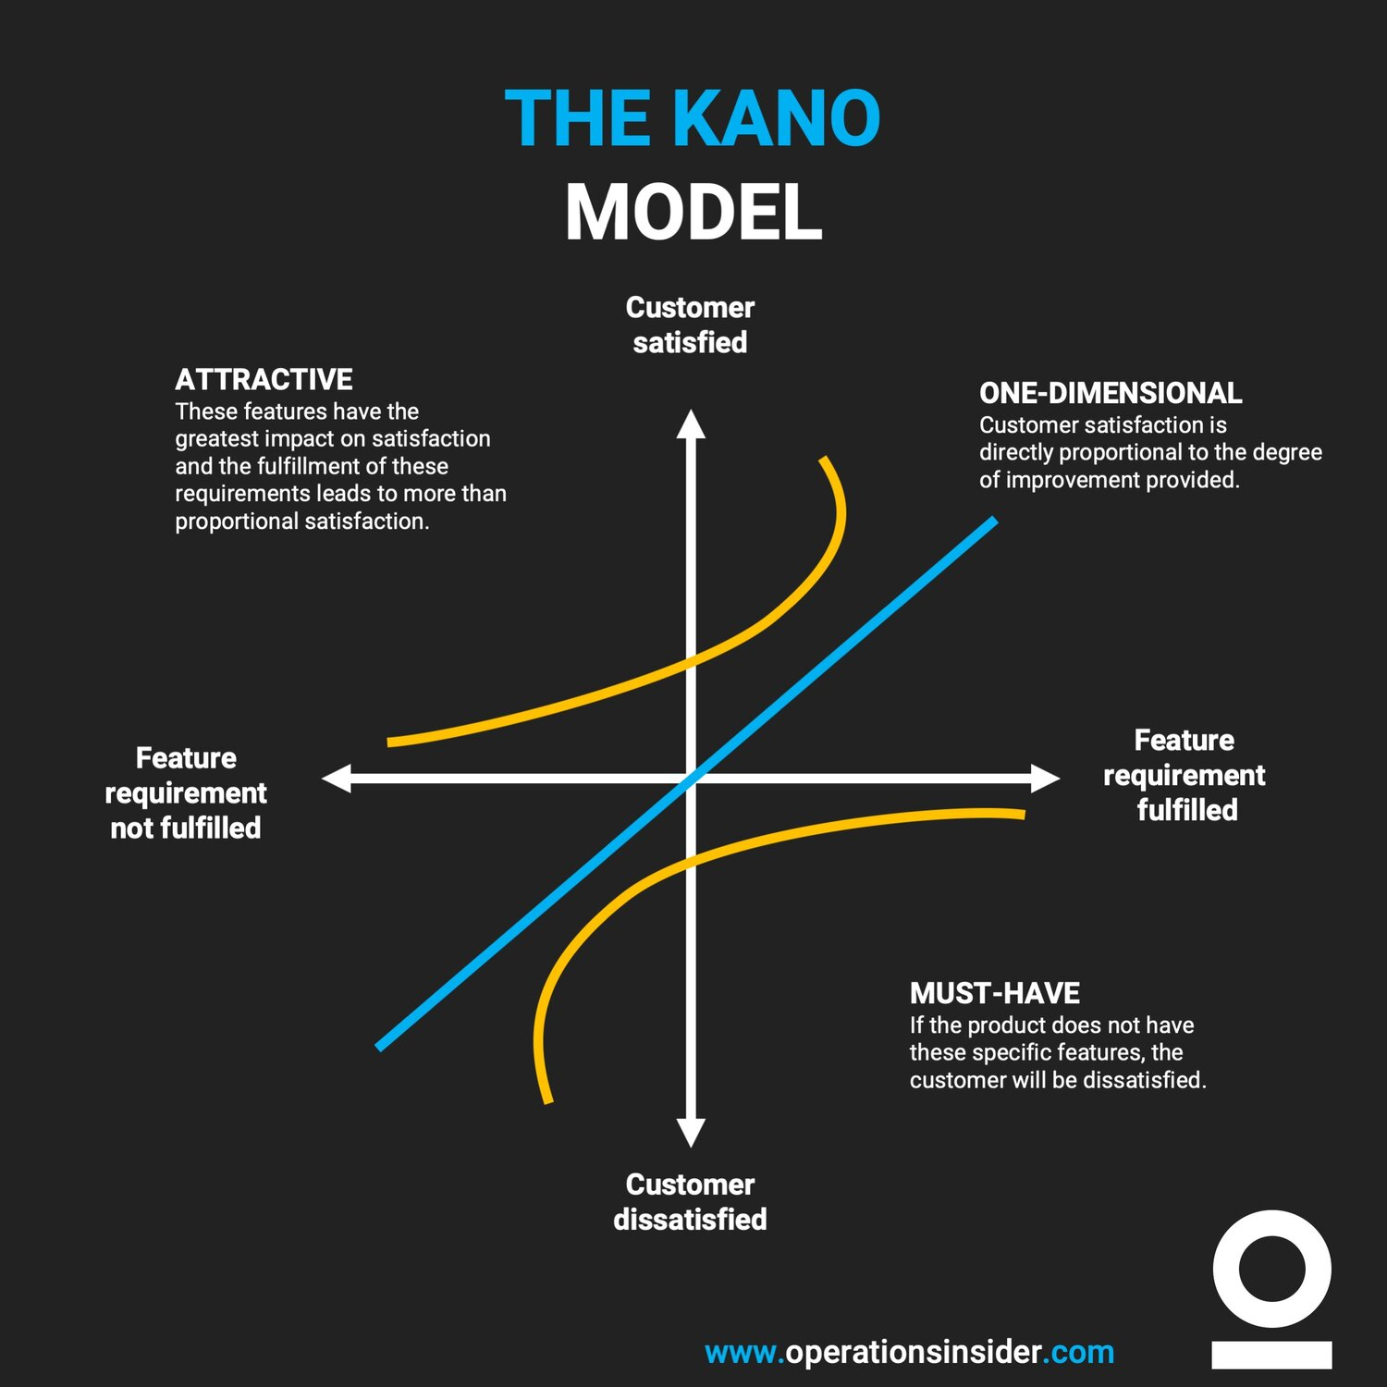
   * Imagine you’re designing a food delivery app:
     + **Must-be Quality**: Accurate delivery time estimation.
     + **One-dimensional Quality**: Variety of restaurants and cuisines.
     + **Attractive Quality**: Surprise discounts or personalized recommendations.
     + **Indifferent Quality**: Basic features like order tracking.
     + **Reverse Quality**: Annoying notifications or slow app performance.

**For more:**  
To gain proficiency in problem-solving with these frameworks, you can:

1. **Study Case Studies**: Look for case studies where these frameworks have been applied. Analyze the decisions made and the outcomes achieved.
2. **Apply Them to Hypothetical Scenarios**: Create hypothetical product scenarios and apply each framework to see how they would guide your decision-making.
3. **Real-world Application**: If possible, apply these frameworks to real-world situations in your current role or a side project. This hands-on experience is invaluable.

Since you have experience with Python, you might